Build a Raspberry Pi Plant Monitoring solution with Bluemix using the Internet of Things Boilerplate and Cloudant
Notes:
- Before you get started, click File > Properties > Description, and specify your tutorial title and keywords.
- Use the cursor keys to traverse the document while watching the style information in the toolbar. This way, you can make sure that your styles, including any custom dW styles, are correct. This will enable the dW team to cleanly convert this document to a publishable format.
- Please speak to your editor before deviating from this simple template and structure in any way.

Introduction
Provide a brief introduction to your tutorial. Describe why you created the application (what problem does it solve), what service(s) you're using and why, and how the reader can benefit from reading the tutorial.
The Poseidon project is a voluntary initiative that aims to reduce water usage in the world. As a first step the project developed an Internet of Things solution and education material for monitoring the water in the soil of your plant at home. A mobile app will notify you when your plant needs watering in advance. The objective is to build an enthusiastic community that is focused on the finding solutions that reduce water usage by applying the use of technologies like internet of things, cloud, mobile and analytics.
For this tutorial we will be using:
- a Raspberry Pi, with GrovePi extension board, a temperature/barometric sensor and a soil moisture sensor. You will need beginner Python skills to understand the client scripting code.
- Bluemix as a cloud platform to run our our application; we will be using the Internet of Things template to store sensor data and send tweets.
The Poseidon project is the first project of the Dutch Courage foundation to educate students at 15 universities throughout Asia about the use of this technology. A part of the team will be driving through Asia (Russia, Mongolia, Kazakhstan, Uzbekistan and other countries) to provide this education. The objective is to stimulate students to join the community and extend the Poseidon platform.
In the process of this trip, we expect to lecture at some 15 universities in the region, challenging them to work with us on this global problem
Action BH: to finish – use picture below to describe context. Extend picture to include Bluemix service names + DevOps + central vs decentral + maybe how to fork repo, etc. Maybe use system context?
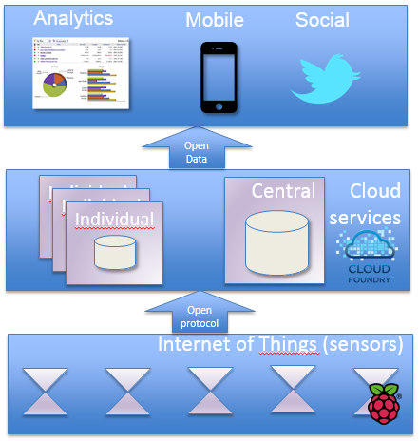

What you'll need to build your application
The monitoring solution is based on a standard Raspberry Pi with a GrovePi extension and sensors that you can order from Seeed Studio or Dexter Industries.
You will need the following hardware to build the solution:
- Hardware, approx $80
  - Raspberry Pi Model B, SKU: 800025001, $40
(Model B+ was released later but will probably work as well)
  - Optional: Raspberry Pi Power Supply (mini USB), $5
  - GrovePi extension board for Raspberry Pi, SKU: 830004001, $25
  - Grove - Barometer (High-Accuracy) (includes temperature), SKU: 811027001, $20
  - Grove - Moisture Sensor, SKU: SEN92355P, $5
  - 4GB SD Card, $15
  - Optionally, a HDMI cable to connect the Pi to your TV or monitor.
  - Optionally, an Ethernet network cable
  - Optionally, a USB mouse and keyboard for the (one-time) configuration of your Pi.
- Familiarity with Linux and Python.
- A Bluemix account
- A DevOps Services account
- A working Internet connection and a switch to connect the Ethernet cable from the Pi to

Provide the following here:
- The URL to your running app: http://poseidon.mybluemix.net/
- The URL to get your code in DevOps Services: https://hub.jazz.net/project/bbhavers/PoseidonProject/overview

Do not modify the buttons below.
Run the app

Get the code
https://hub.jazz.net/project/bbhavers/PoseidonProject/overview

Step 1. Setup Raspberry Pi
In the next sections, describe, step-by-step, how to create the application. Use screen captures to illustrate and enhance the steps, where helpful, but never to replace the text. For accessibility reasons, all steps must be described in text. Make sure that all images have a Title set in the Description field for use as alt text (for accessibility).
- Use numbered lists to order sub-steps.
- Second item

The Raspberry Foundation makes installation of the Raspberry Pi as easy as possibleby providing the NOOBS (New Out Of The Box) installer. The NOOBS installer contains various Operating Systems for the Pi that can be installed with a few choices. There are two variants of the file:
- an Offline version that contains all the data in one file in case no network connection is available,
- a Network install that downloads the latest Operation System when installing your Pi.

- Setup your Raspberry Pi, ready to install the operating system
  - Connect the Pi with the HDMI cable to a monitor or TV
  - Connect an Ethernet network cable
  - Connect your USB mouse and keyboard
  - Connect the power supply
- Setup your Pi according to the instructions on for installing NOOBS: http://www.raspberrypi.org/introducing-noobs/
The tutorial will take you through the following steps
  - Download the NOOBS install package
  - Format the SD Card on your computer with the SD Card Formatter application from https://www.sdcard.org/downloads/
  - Copy the extracted NOOBS zip file on the SD Card and install the card in the Pi.
  - Install the Raspian Operating System
  - Verify that you can connect and log into to your Pi using SSH.
- Configure the GrovePi extension board, following the instructions of Dexter Industries, the manufacturer of the GrovePi: http://www.dexterindustries.com/GrovePi/get-started-with-the-grovepi/setting-software/. The tutorial will take you through the following steps:
  - Do not yet connect the GrovePi extension board.
  - Clone the GrovePi github image in your home directory
git clone https://github.com/DexterInd/GrovePi.git
  - Move the the directory that contains the configuration script
cd GrovePi/Script
  - Make script executable
sudo chmod +x install.sh
  - Execute GrovePi configuration script.
sudo ./install.sh
  - The Pi will restart after running the configuration script. Power the the Pi down to install the hardware
    - Connect the GrovePi extension board
    - Also connect the sensors, the Barometer to port I2C-1 on the GrovePi extension board
    - Connect the Moisture sensor to port D8 on the GrovePi extension board
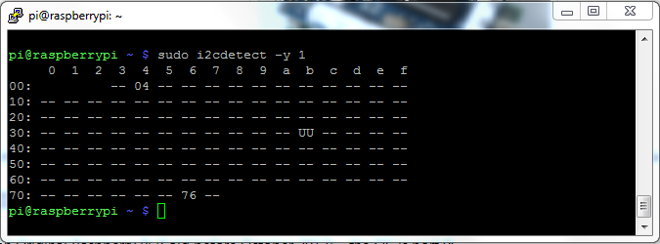
  - Verify if the extension board is detected by running
sudo i2cdetect -y 1
It will show the value 04 when it is connected.
The hardware is now configured. Now we need to install the script to send the data from the sensors to a central cloud service for further processing.

Step 2. Install Poseidon Client script to send data to the cloud
We will use MQTT to send sensor data to the IBM Internet of Things cloud. MQTT is a light-weight publish/subscribe messaging protocol, see mqtt.org. MQTT clients are available as the Paha project in many different languages, including Python that we will use
- Install additional packages
  - Install MQTT client libraries.
sudo pip install paho-mqtt
  - TBD: continue from here next time. Git clone

Action BH: finish installing script + autoboot.

Step 3. Setup Bluemix environment
In this step we are going to setup the Bluemix environment. IBM® Bluemix™ is an open-standards, cloud-based platform for building, managing, and running apps. You can create these apps by reusing the services that Bluemix offers like datastores, analytics service, mobile or visualisation services. The platform supports various application platforms like Java and Node.js and is extensible through build-packs. In this tutorial we will use the following services:
  - Node.js - a server side platform to run Javascript application on.
  - Node-RED - provides the ability to visually wire together nodes (functionality) in a browser. We will use it to wire incoming sensor data to a database to store the data and to a tweet node that submits data to Twitter.
  - Cloudant - is a NoSQL cloud database, based on CouchDB.

- Register for a Bluemix account
- Browse to http://bluemix.net/ and click Sign Up
- After clicking the validation, login to your Bluemix account.
- After we've set up our Bluemix account it's time to create the Internet of Things application.
Login to your Bluemix account and navigate to the App dashboard.
Click on “Create an App”.
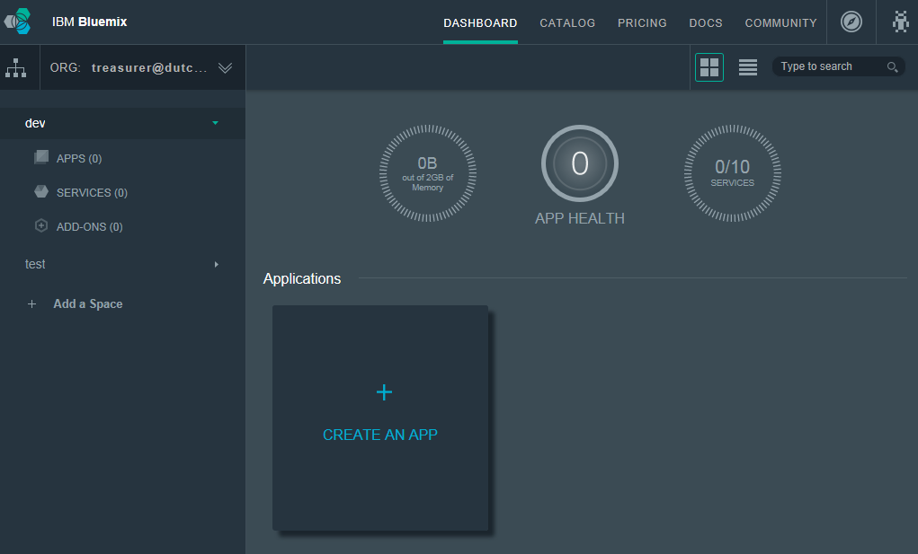
- ​Select the “Internet of Things Foundation” Boilerplate from the Boilerplates list.
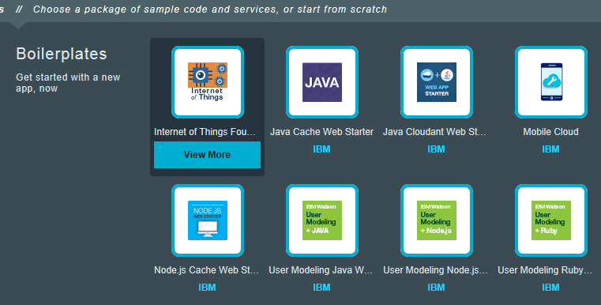
The Internet of Things Foundation boilerplate provides the Node.js Runtime, the Node-RED Application and creates an instance of the Cloudant NoSQL Database

- Enter the name and the hostname of the App. Leave everything else as default and click Create.
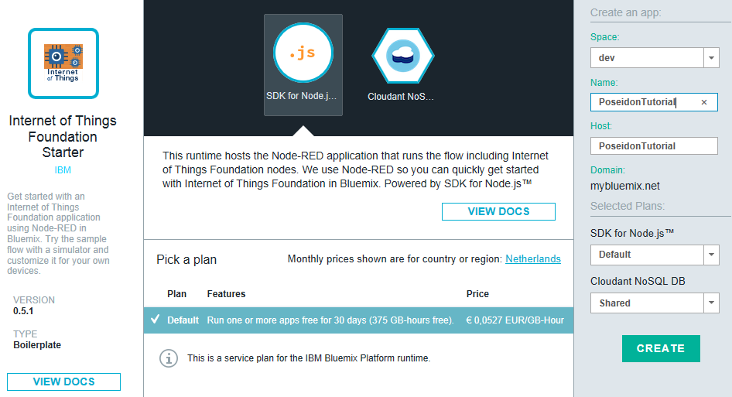
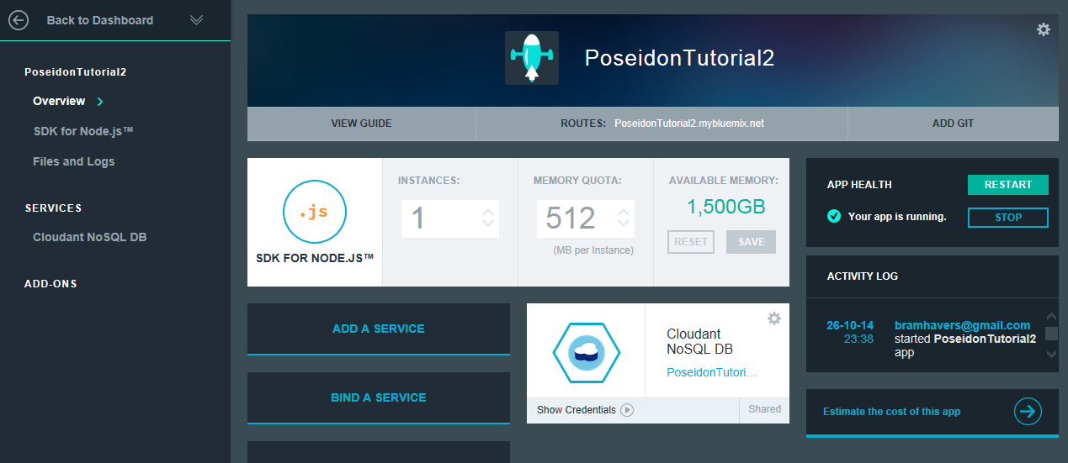
- Our App is now being provisioned. After some time the app will automatically start.
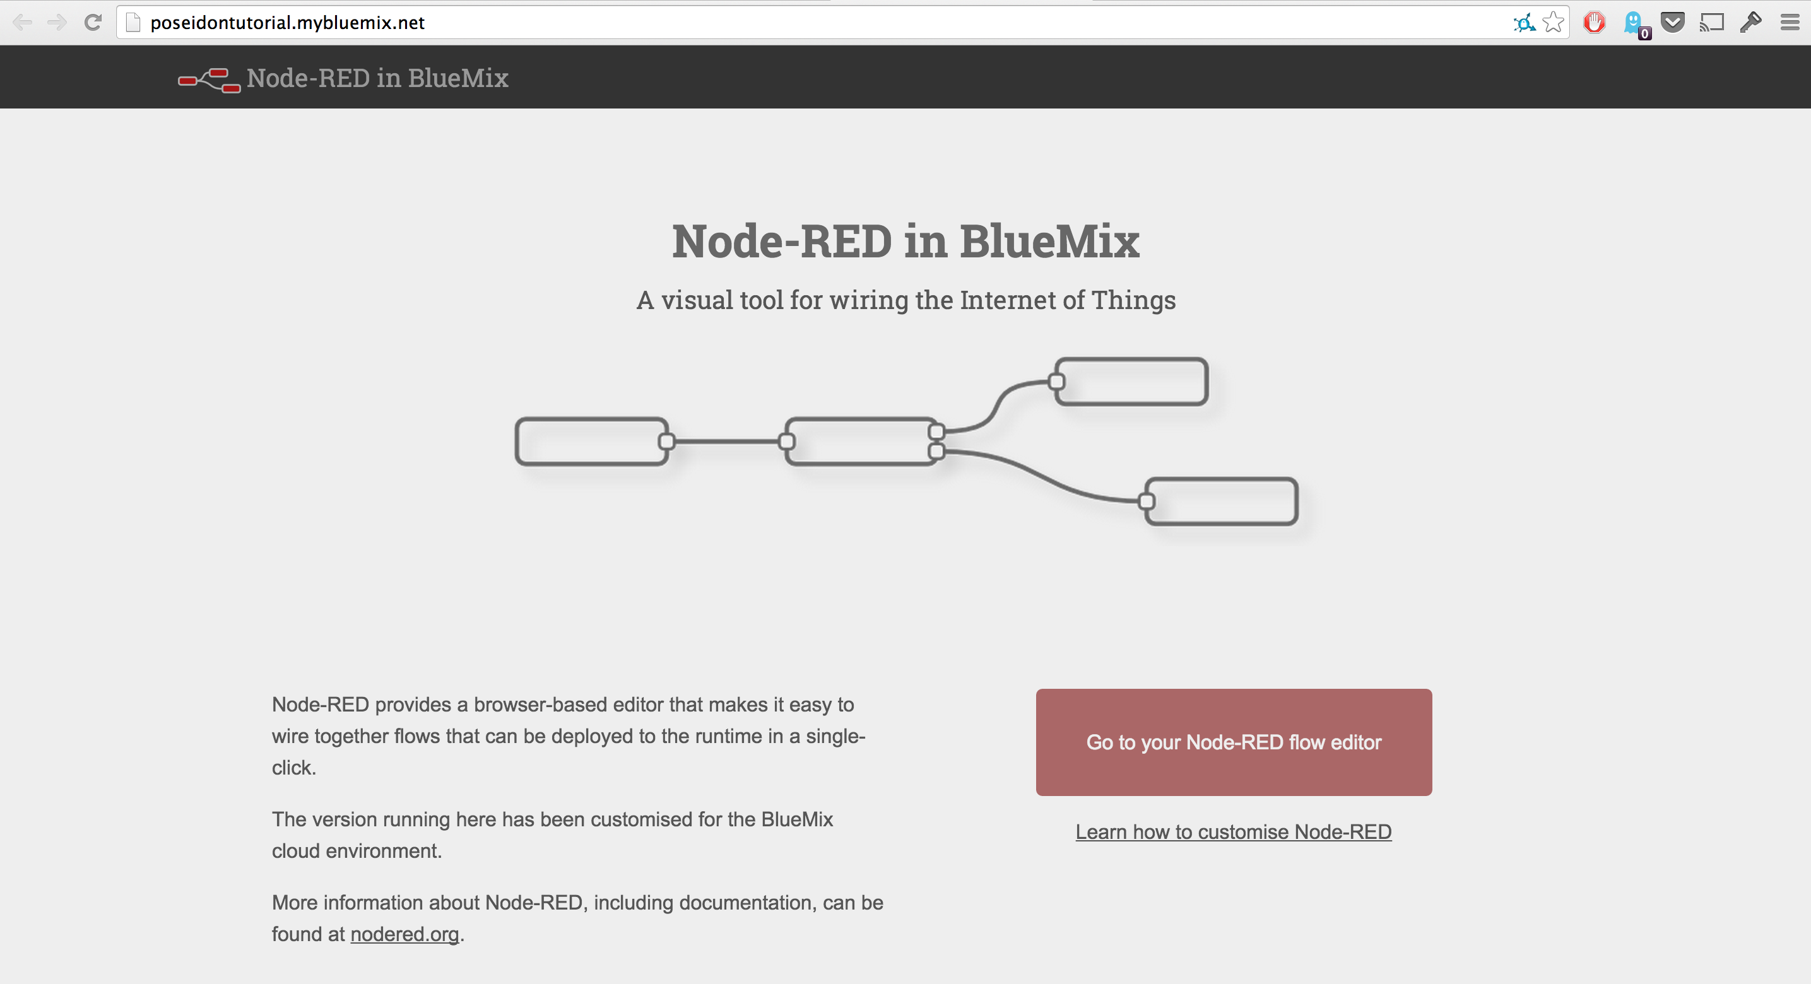
- Now that our Internet of Things application is running we can navigate to the website by clicking on the path behind Routes (PoseidonTutorial.bluemix.net). This will open a browser, by which you are able to configure the Node-RED service instance.
Click Go to Node-RED editor
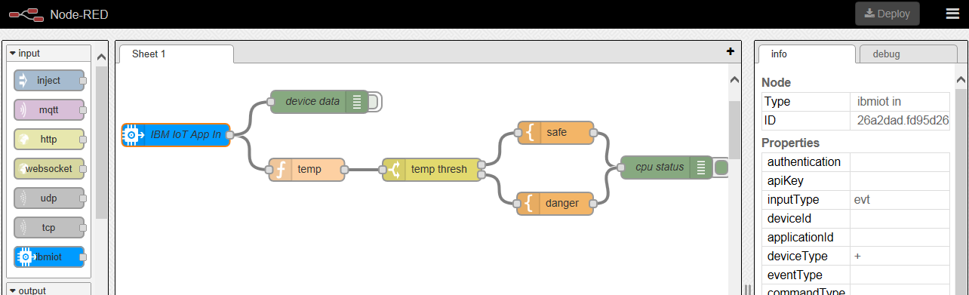
- In the Node-red editor you will see a default Internet of Things flow drawn, with on the left hand the list of available nodes (input and output 'connectors' and functions to perform on input data or to produce an output). On the right hand side you will see the properties of the selected node in the the worksheet.
Select all nodes in the sheet (by holding shift and selecting all nodes) and press Delete to remove them from the sheet.
Stay logged into Node-red, you will need this in the next step.

Step 4. Configure Bluemix to store data
In this step we will configure our Bluemix environment to receive sensor data and save it to a Cloudant database.
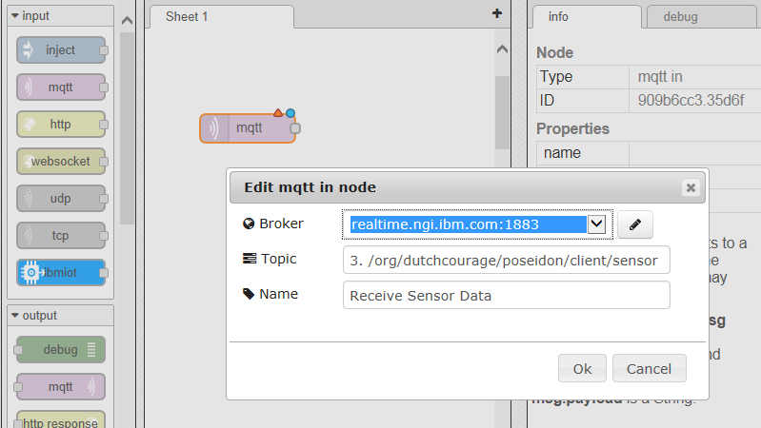
- We are going to create a node that starts with receiving data from an MQTT broker (the Poseidon client on the raspberry Pi is publishing the sensor data to a MQTT broker).
Click and drag the Input mqtt node onto the sheet.
- Double click the MQTT input node and enter the following settings:
  - Broker: realtime.ngi.ibm.com (no client id and no userid and password)
  - ClientID: choose your own unique id, for example MyPoseidon23.
  - Topic: /org/dutchcourage/poseidon/client/sensor
  - Name: Receive Sensor Data
- Add a debug node to the flow, and connect it to the Receive Sensor Data (mqtt) input node.
The Debug node will display the received messages in the debug tab on the right hand side of the editor. The blue circles are an indication that the node has been added (or changed) and has not yet been deployed.
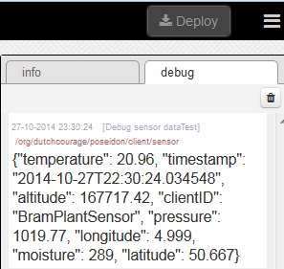
- Deploy the flow to test it: in the upper righthand side of the editor click on “Deploy”
Now watch the Debug tab on the right for incoming messages. You might want to restart the Poseidon client on your Raspberry Pi to trigger it to send new values (by default it is sending messages once an hour). See earlier paragraph on restarting the client.
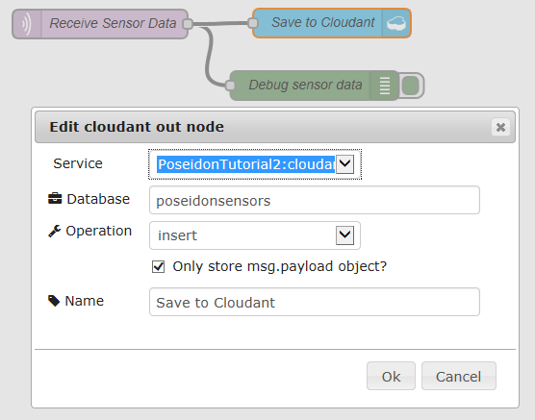
- After you have successfully tested that data is coming in, add this data to the Cloudant database by adding the Cloudant Out node to the flow. Connect it to the Receive Sensor Data node.
- Double click the Cloudant out node to edit its parameters:
  - Service: select your Bluemix Cloudant instance.
  - Database: poseidonsensors
  - Check Only store msg.payload object?
  - Name: Save to Cloudant
- Deploy the flow to activate it and store data in the Cloudant database: in the upper righthand side of the editor click on “Deploy”
- To view our saved data in Cloudant, we navigate back to our Bluemix account. On the dashboard we can see our Cloudant instances listed under the Services Section.
  - Click on the Cloudant instance.
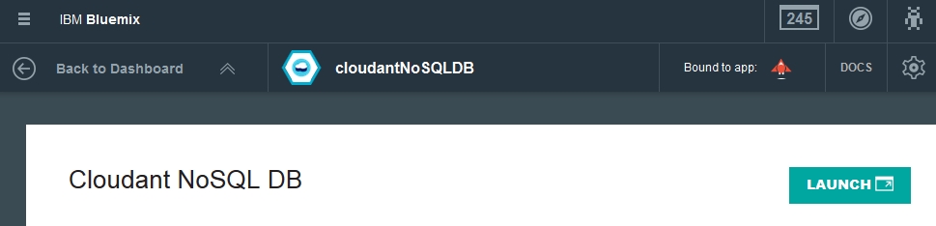
  - Click on the “Launch” button on the Cloudant service view.
- We are now on the Cloudant Dashboard where we can create new databases, create Replication tasks and view and edit database entries.
To view that sensordata click on the “poseidonsensors” database (which is created by the Cloudant Out node).
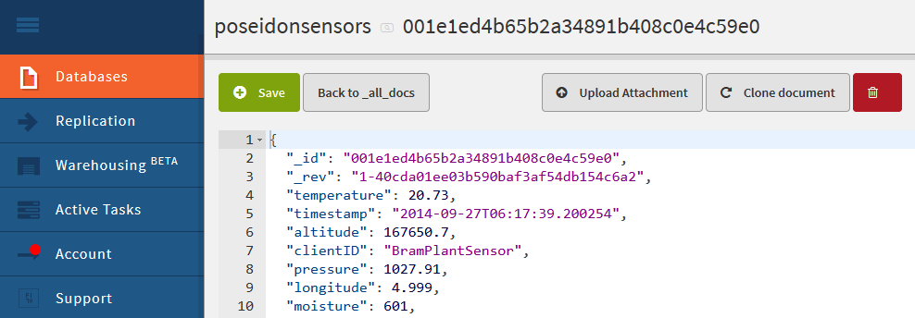
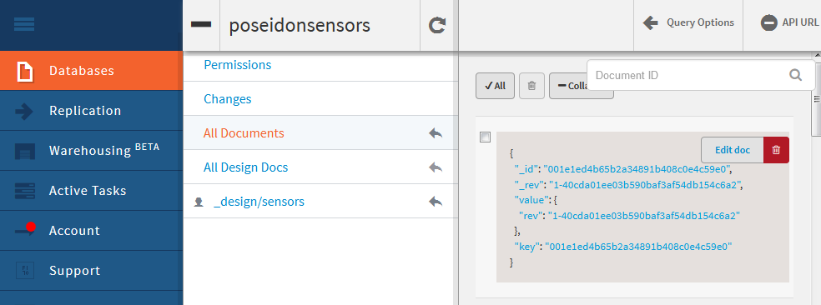
- To view the actual sensor data, move over the document and click the “Edit doc“ button that appears on the top right corner of the document.
You will now see the json data structure and contents of the document.
Your data is now stored into the database.

Step 5. Configure Bluemix to send tweet
Now that our NodeRed Instance is up and running we can extend the flow to publish the received MQTT messages on Twitter.
- Open your browser and navigate to the NodeRed Flow.
- Click on the Menu Button in the upper right side of the flow editor. Select the option “ Import...” → “Clipboard”
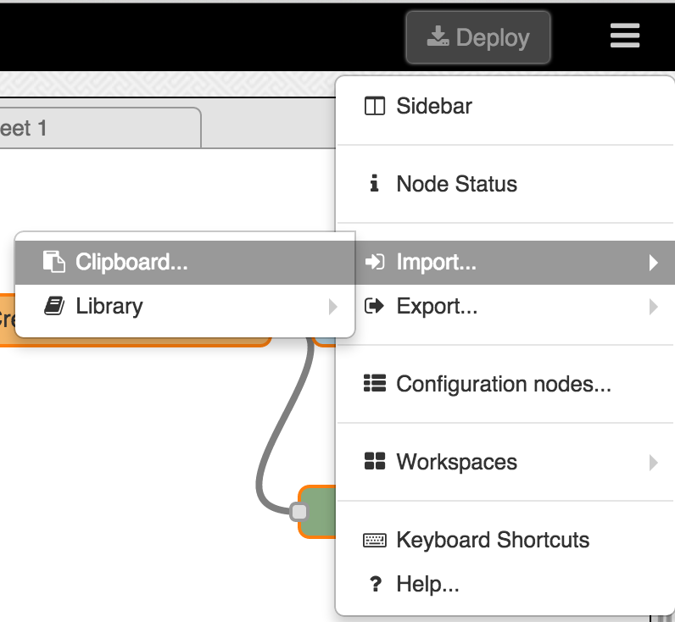
- Copy the contents of the “NodeRedFlow.txt” in to the field and click “OK”
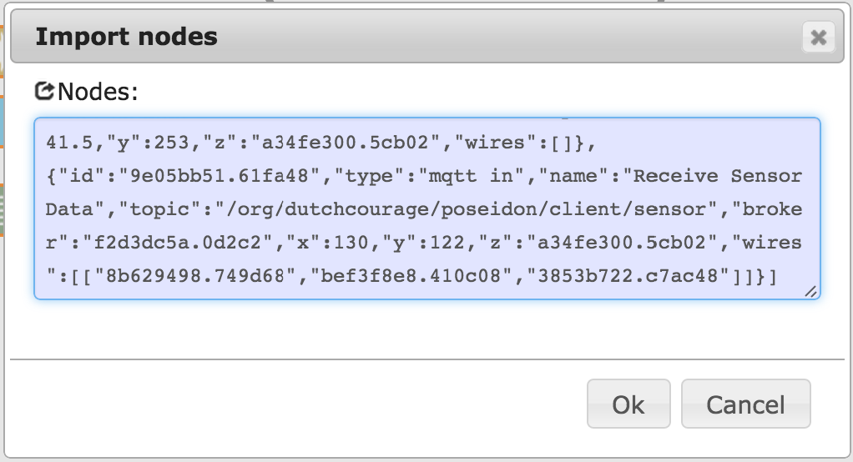
- Double click on the Twitter Node and click on the pen Symbol to authenticate your Twitter account with NodeRed.
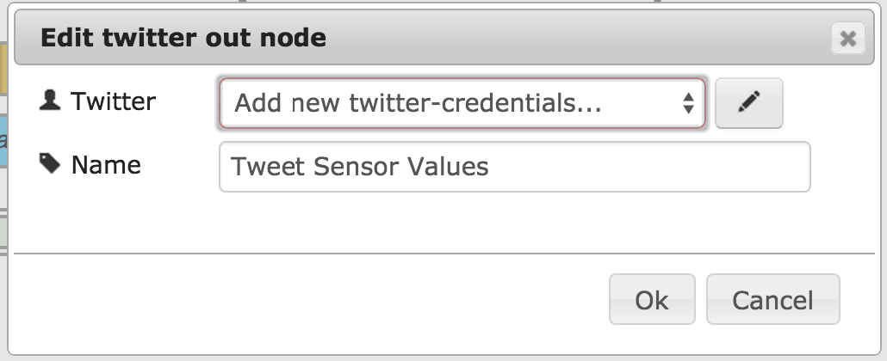
Follow the steps on Twitter.
- Click on “Deploy“ on the upper right side of the editor to save the changes.

Step 6. Secure Node-red
The Node-red editor is currently not protected by a password available on the internet. In this step we will set a password to Node-red. This involves modifying the configuration settings of our Bluemix instance. We will the auto-deploy option of the Bluemix development environment, called DevOps to synchronize the Bluemix instance data (application and configuration code) to a Git repository and the vice-versa.
Changes you make to the Bluemix configuration in Bluemix will be versioned (committed) in Git and automatically deployed to your Bluemix instance.

- Generate a MD5 Hash of the password for Node-red
Preferably use a computer in your control to generate a MDD5 hash. For education purposes you can use an MD5 Hash Generator on the internet, like http://www.md5hashgenerator.com/
- On Bluemix, add a Git repository for your application.
- On the Bluemix Dashboard homepage click on your Application
- Click Add Git button on the right
- Go to the DevOps development environment
  - In the Bluemix Dashboard click on the Git URL or Edit Code button.
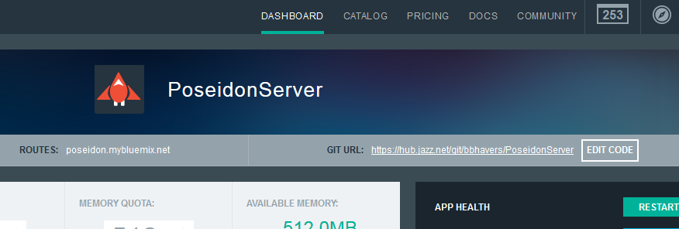
  - If you don't have an Jazz (DevOps) userid you will be prompted to enter you Bluemix password, followed by a Jazz userid.
  - You will have to confirm that all your changes will automatically be pushed to Bluemix. Confirm this by clicking on Continue.
  - After the DevOps (Jazz) setup is done, you might have to click the Git URL again to login.
- Change userid and password
  - You will the edit the configuration of your application, click Edit Code.
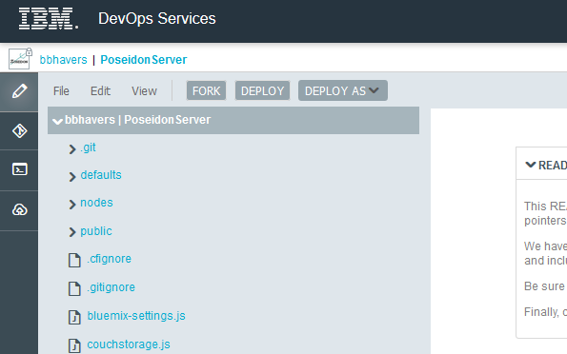
  - Click bluemix-settings.js
The file will become available for editting on the right side.
  - Uncomment the httpAdminAuth property (remove the // before) and set your username and the MD5 hash you have just created.
- Test the changes on your Bluemix environment
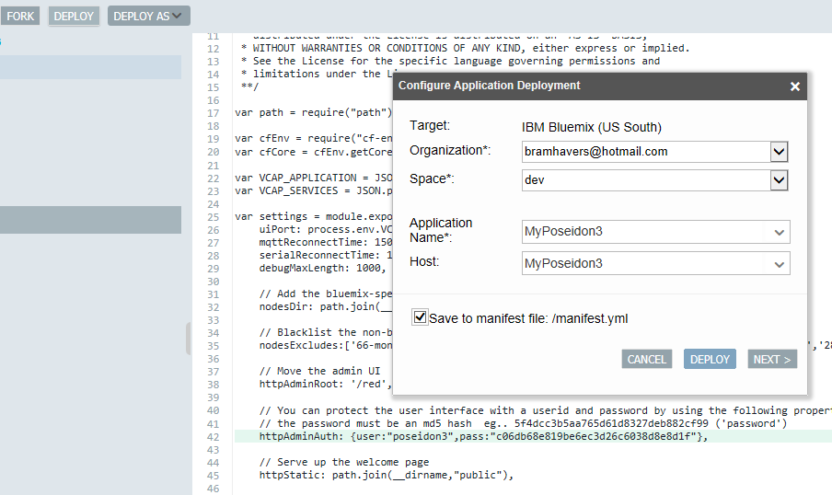
  - Click Deploy
The changes to the code are stored automatically.
- Test to see if it works.
  - Go to Bluemix dashboard and click on the link that brings you to the homepage of your application.
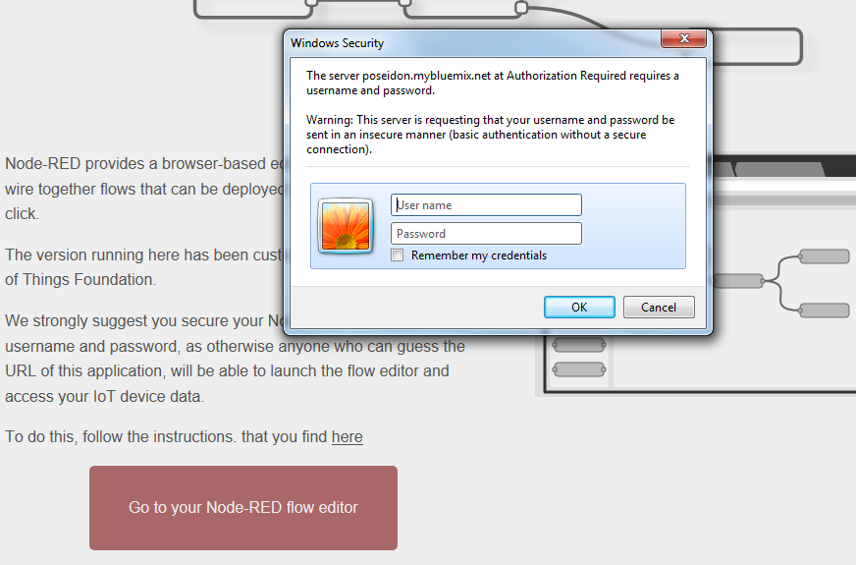
  - Click on Go to your Node-Red editor
You should now be asked for your user-id and password
  - Login with user-id and password that you have just provided.
- Commit the code to git
You have been changing the bluemix-settings.js file on your 'local' working directory. The changes have not been committed to your code repository yet. You have worked with your local (but on DevOps environment using the WebIDE) version. Commit the code to git to make it visible for everybody. It will be auto-deployed (again) to your Bluemix instance.
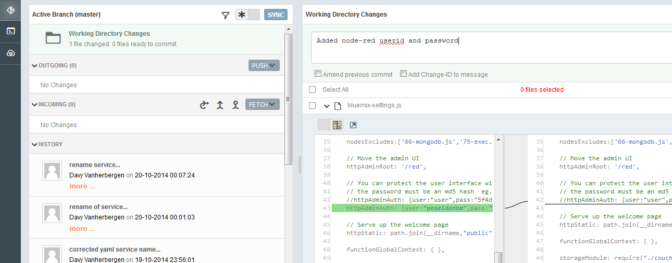
  - Go to DevOps again and select the Git Repository (2nd) icon on the left side of the screen
  - On the right side you will see the file that you have changes (bluemix-settings.js) and the line in the code that changed. You are going to add (commit) all changed files to the the the to Git repository.
Check the Select All checkbox.
  - Enter a commit message
This makes clear to other developers what you have changed
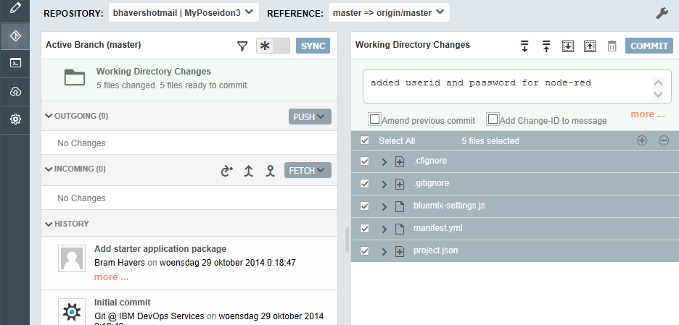
  - Click Commit
This will add (commit) the changes on your 'local' working directory, but will not yet upload (push) them to the Git repository.This way you can locally (or in this case in the Web editor) collect all your changes (commits) and push them all at once to the repository. This is convenient if you are working offline for a longer term, but it is also good practice to commit and push often. So others are aware of your changes.
  - Click Push
This pushes your changes in the git repository and will trigger auto-deployment on your Bluemix instance.
  - Check Status of deployment
Click on your projectname to go to the home of your DevOps project, and click on the Build & Deploy buttong.
You should see a line with your last commit deployed.
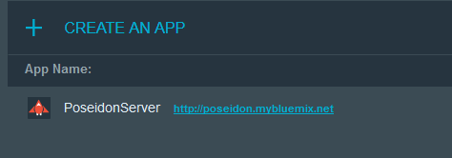
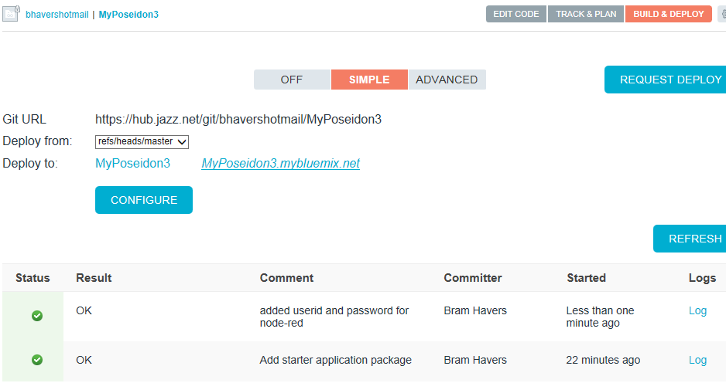
  - Validate once more that Node-red is password protected.

Conclusion
Briefly summarize the tutorial. What did the reader learn and how can they apply it? What are the benefits?
Action BH+KW+Bill: tbd

Appendix
This appendix describes styles to use for common tutorial elements.

Heading 2

Heading 3

Heading 4

Lists
- Bulleted lists
- Second item

- Numbered lists
- Second item

Links
Use character style Internet Link from the HTML Styles group.
Build a sentiment analysis application with Node.js, Express, sentiment, and ntwitter
A button to associate the URL with your link is in the toolbar:

Use cross references if you need to link to a heading in another part of your tutorial.

Highlighting
- Use bold and italic text when needed.
  - Use a monospace font (custom character style dW Source) for code elements in a sentence.
- Use a footnote for tooltips

Code listings
Use custom character style dW Source.

|-------10--------20--------30--------40--------50--------60--------70--------80--------90-------100----|
THIS RULER LINE ABOVE IS 105 CHARACTERS LONG. IT USES 8PT MONOSPACED FONT.
Use HTML style Preformatted Text or custom paragraph style dW Code listing

Images
Put small images such as icons inline.

Put larger images in a paragraph of their own.
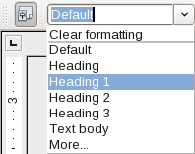

- You can also put images at the end of a list item.
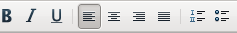

Tables
A button to create a table is in the toolbar.
Item | Unit of measure | Price
Paper | Ream | $17.95
Rubber bands | Bag | $4.27

Sidebars
Text in a frame such as this will be displayed in a sidebar.

Action blocks (READ and WATCH)
Custom character style dW Action block
Including link text directly in a sentence is the norm, but you can also use blocks (sparingly).
READ: Node.js beyond the basics
WATCH: Getting started with Node.js (demo)

Please provide the following for each author. Use a separate table for each author.
Prefix:
Given: | Bram
Middle:
Family: | Havers
Suffix:
Job title: | IT Architect
Company name: | IBM Netherlands
dW profile: | https://www.ibm.com/developerworks/community/profiles/html/profileView.do?key=b275c5f8-4e62-4a4f-9ea9-cd48466cc1bd
Twitter: | Uhttps://twitter.com/bbhavers
Google+: | https://plus.google.com/u/0/108089817337791750922  https://plus.google.com/100028886433648406825/about)  Notice how this author is identified as a contributor to developerWorks under “Links” in his Google+ profile. (By claiming authorship of developerWorks content and listing developerWorks in your Google+ profile, the Google search rank of the tutorial improves). Read details: https://plus.google.com/authorship
Photo filename: | headshot1.jpg
Email address: | bram_havers@nl.ibm.com

Provide an abstract for your tutorial here. This won't appear in the published HTML, but will appear in the PDF, the developerWorks library view, and search results. Summarize why the reader would benefit from your tutorial, or what business problem would be solved. Be succinct (no more than 5 sentences), and include keywords or key phrases that will help external search engines find your content.

Use a tooltip to define a technical term for the reader.

